September 4, 2008

Brian Menges
Director of Jail Administrations
Bexar County, Texas
200 N. Comal
San Antonio, Texas 78207

Dear Mr. Menges

I am requesting permission to perform a research project as part of my Master of Science
in Interdisciplinary Studies graduate program at Texas State University. I will perform
social research on the attitudes, perceptions, and challenges of incarcerated inmates
located at the Bexar County jail.

The research project will be conducted over a two semester period beginning Spring 2009
and concluding in Fall 2009. This project will be performed in coordination with the
Texas State University. The results and recommendations are expected to provide
valuable information and I am hoping that the time required for performing the tasks will
be considered a benefit to the University’s mission and goals. The project will require a
minimum of 13.3 hours per week during both semesters and will be accomplished outside
of normal work hours.

I will also be requesting approval from the University’s Institutional Review Board in
Fall 2008 in reference to the county inmates incarcerated and attending Human services
programs on the seventh floor.

I appreciate your support and approval to perform this research project.

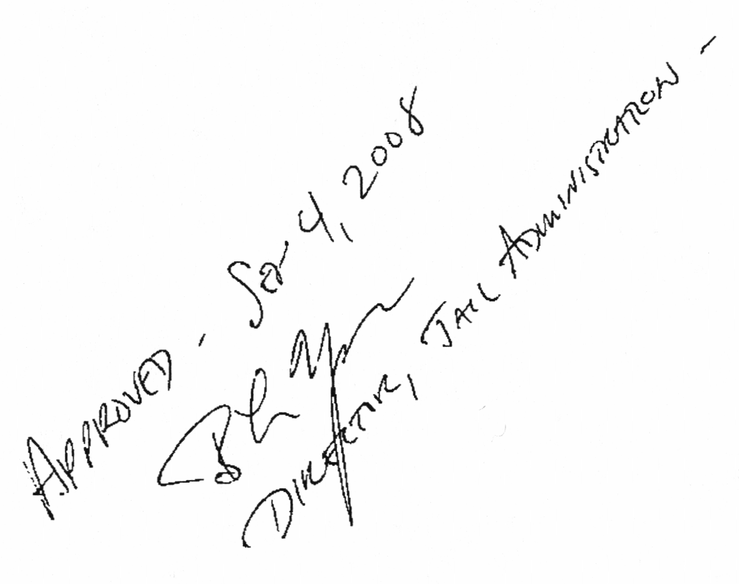
Sincerely,

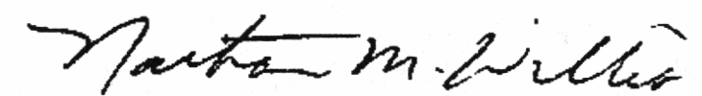
Nathan M. Willis
Master of Science in Interdisciplinary Studies
Graduate Student
Texas State University
601 University Drive
San Marcos, Texas 78666

nmw

